SRS Document

## Use case Diagrams

## Use case specification

### Use case RentBike

| UseCase | RentBike |
| --- | --- |
| Summary | User will make request to rent a bike and pay some deposit money depend on bike type |
| Actor | User, Interbank |
| Precondition | User have card and internet |
| Postcondition |  |
| Base Sequence | 1. User make request to rent a specific bike  2. Software will display the form for user to enter some information like: barcode and payment information  3. User enter require information to the form and submit to the system  4. Software check the information and make a request to interbank to process payment  5. Interbank will check the payment information and deduce the deposit money  6. Software will save the transaction information and display success message to user |
| Branch Sequence |  |
| Exception Sequence | 6A.1 Software will display error: Invalid payment information  6A.2 Return to 2  6B.1 Software will display error: Invalid bike barcode  6B.2 Return to 2 |
| Sub UseCase |  |
| Note |  |

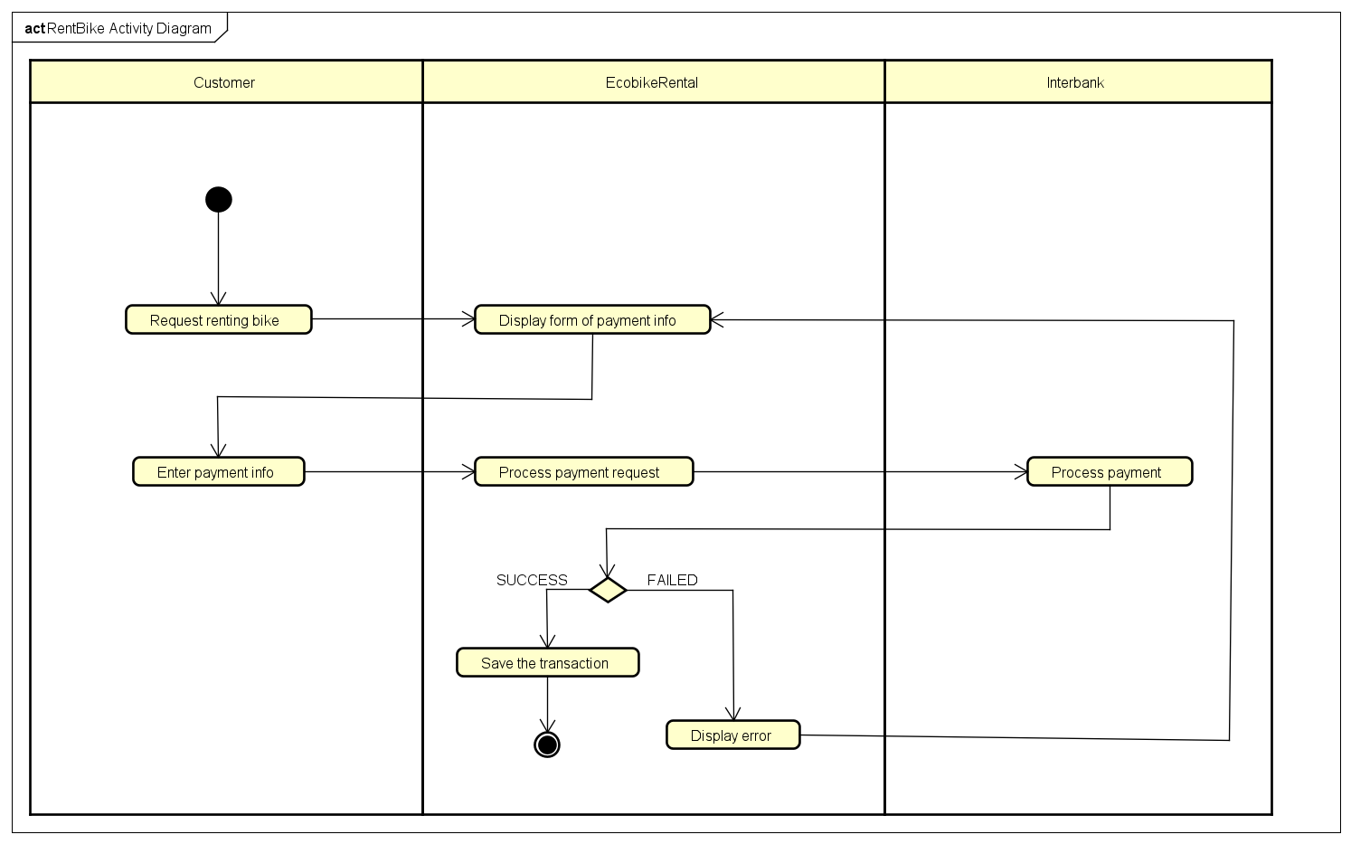

### Use case CheckBikeStatus

| UseCase | CheckBikeStatus |
| --- | --- |
| Summary | User can check the information of rent bike. If the bike is electric bike, software should display its remaining charge. |
| Actor | User |
| Precondition | User has connect to internet |
| Postcondition |  |
| Base Sequence | 1. User request to check bike information 2. Software process the request and display the information of the bike for user |
| Branch Sequence |  |
| Exception Sequence |  |
| Sub UseCase |  |
| Note |  |

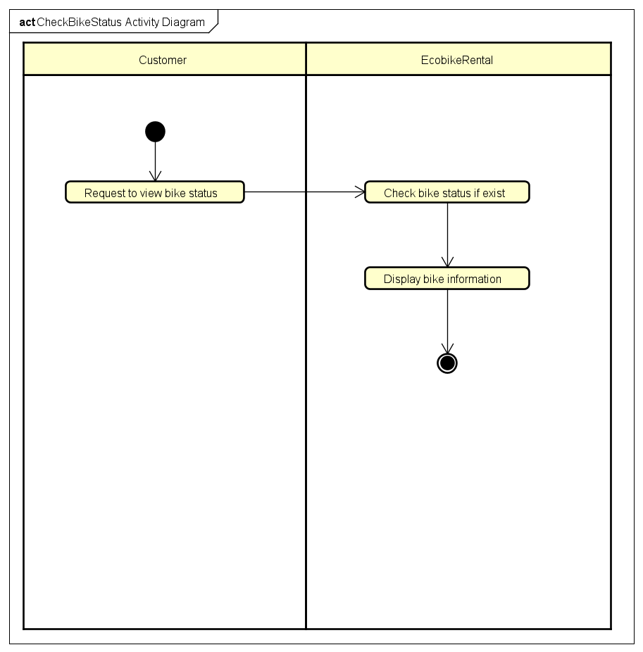

### Use case ReturnBike

| UseCase | ReturnBike |
| --- | --- |
| Summary | User can make request to return the bike |
| Actor | User, Interbank, Admin |
| Precondition | User has connect to internet |
| Postcondition |  |
| Base Sequence | 1. User request to return the bike 2. Software process the returning request and calculate the fee 3. Software process the payment request 4. Interbank process the payment 5. Software will save the transaction and display successful message to user |
| Branch Sequence |  |
| Exception Sequence | 5A.1 Software display error: Not enough money in card 5A.2 End Usecase |
| Sub UseCase |  |
| Note |  |

